**1. Create a new Sign Up on GITLab and create the new Project.**

**a. Clone the system into your local drive.**

**Ans :**

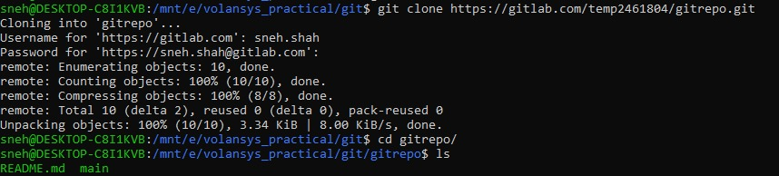

**b. Add a new file.**

**Ans :**

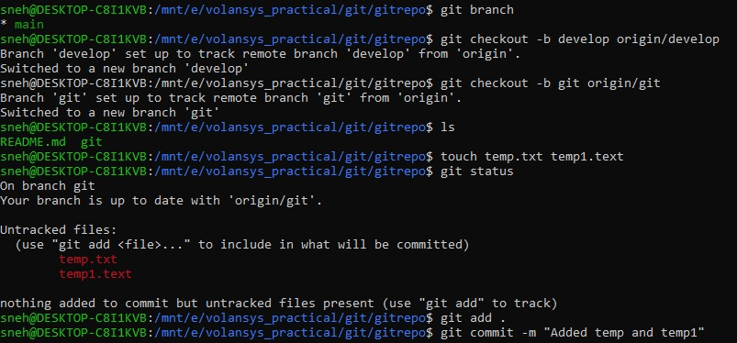

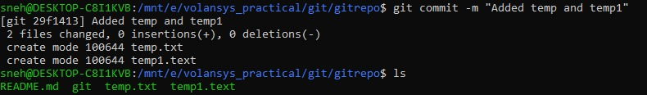

**c. Delete an existing file.**

**Ans :**

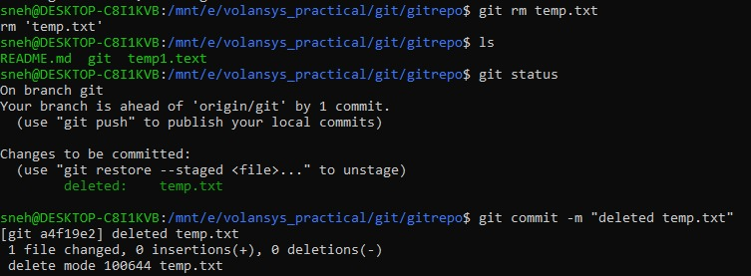

**d. Modify an existing file.**

**Ans :**

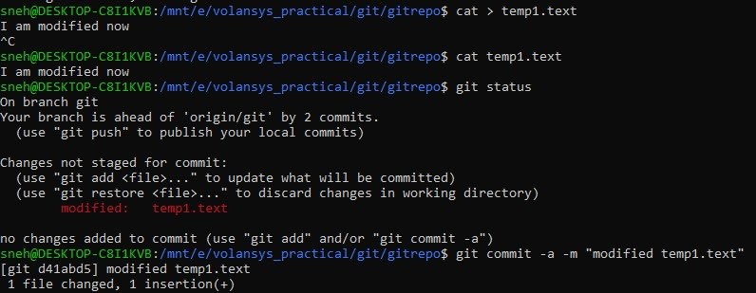

**e. Rename a file.**

**Ans :**

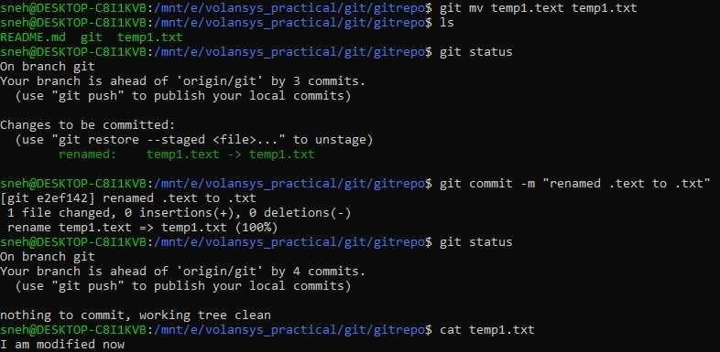

**f. Push the changes to GITLab.**

**Ans :**

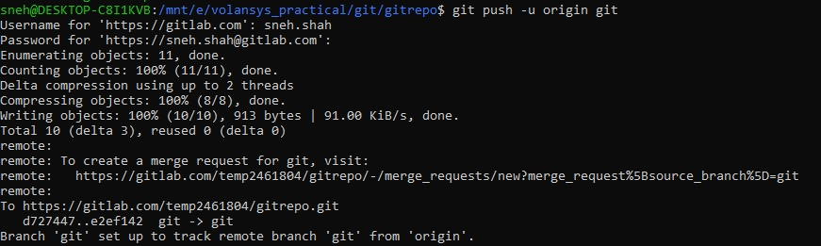

**g. Create a Merge Request.**

**Ans :**

